## Webinar 1_A

## Exercise: List of Students application

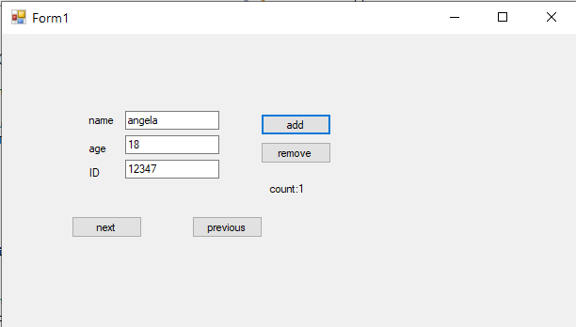

We’ll produce an application to allow adding/removing students to a List, as above. We’ll need some classes, see lecture on classes, below is the start of a Person class. A student should have a name, age and ID number.

class Person : IComparable

{

private int age;

private string name;

public Person(string name) //constructor with one argument

{

this.name = name;

age = 18; //default age

}

public string Name

{

get { return name; }

set { name = value; }

}

public int CompareTo(Object obj) //implementation of CompareTo

{ // for IComparable

Person other = (Person)obj;

return Name.CompareTo(other.Name);

}

}

* Design Student Class
* Implement Student Class
* Implement GUI – through designer
* Add Button Design, then implement
* Remove Button
* Previous and Next Buttons